**Database Design and ER diagrams**

* 1. **Database Design:- The DB design process is divided into 6 steps.**

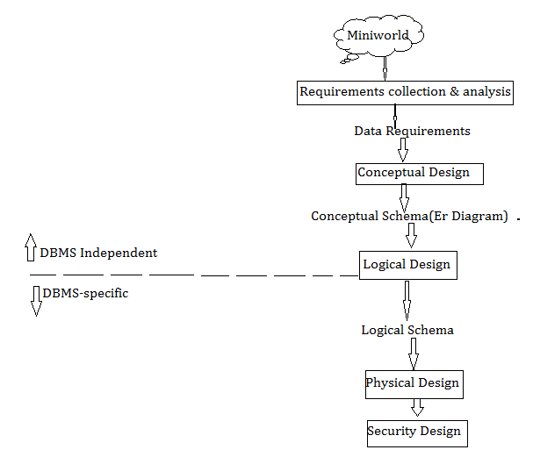

**a. Requirements Collection and Analysis:**This is an informal process that involves discussions with Database users for collecting the requirements.The Database designers understand & document the data requirements of the database users.

**b. Conceptual database design:**The information gathered in the requirements analysis step is used to develop a higher-level description of the data. Using data requirements, Db designer creates conceptual schema in ER-Model.

**c. Logical Database Design**:Under this, we must choose a DBMS to implement our database design and convert the conceptual schema into data model of choosen DBMS.

If we choose Relational DBMS, then we convert the higher-level description of DB from ER-Model to Relational Model.

**d. Schema Refinement:**Under this, we have to analyze the collection of relations in our relational database schema to identify the potential problems.

**e.Physical Database Design:**Physical database design is the process of choosing specific storage structures for the database files(containing the tables).

**Storage Structure of Db file:**

1. The records of table are stored in file as records. We ensure whether records are fixed length records or variable length records.
2. Ensure that how records are stored in file.(i.e)
   1. . Record can be stored any free space infile.
   2. .Records has to be stored sequentially.

…etc.

To achieve good performance for the various database applications, During physical DB design we do following activities(if required).

1.Building indexes on some tables

2. clustering some tables.

3.Redesign the some parts of DB schema.

8

**f. Security Design:**In this step, we must identify different user groups and different roles played by various users.For each role, and user group, we must identify the parts of the database that they must be able to access.